**How to Run myRetail RestfulService**

Prerequisite

* Intellij(or any IDE)
* Java 8
* Mongodb

1. Unzip myRetailSubmission.zip
2. You will see 4 Separate maven project
   1. myretail-price-catalogue
   2. myretail-product-catalogue
   3. myretail-product-nomenclature
   4. discovery-server
3. Since this Project requires mongodb , please start the mongo DB on default port 27017
4. Start all four Spring Boot Application, Start the discovery server first and then there is no order for the rest , please refresh

<http://localhost:8761/>

Running the above URL will show you the similar snapshot , with all the listed client.

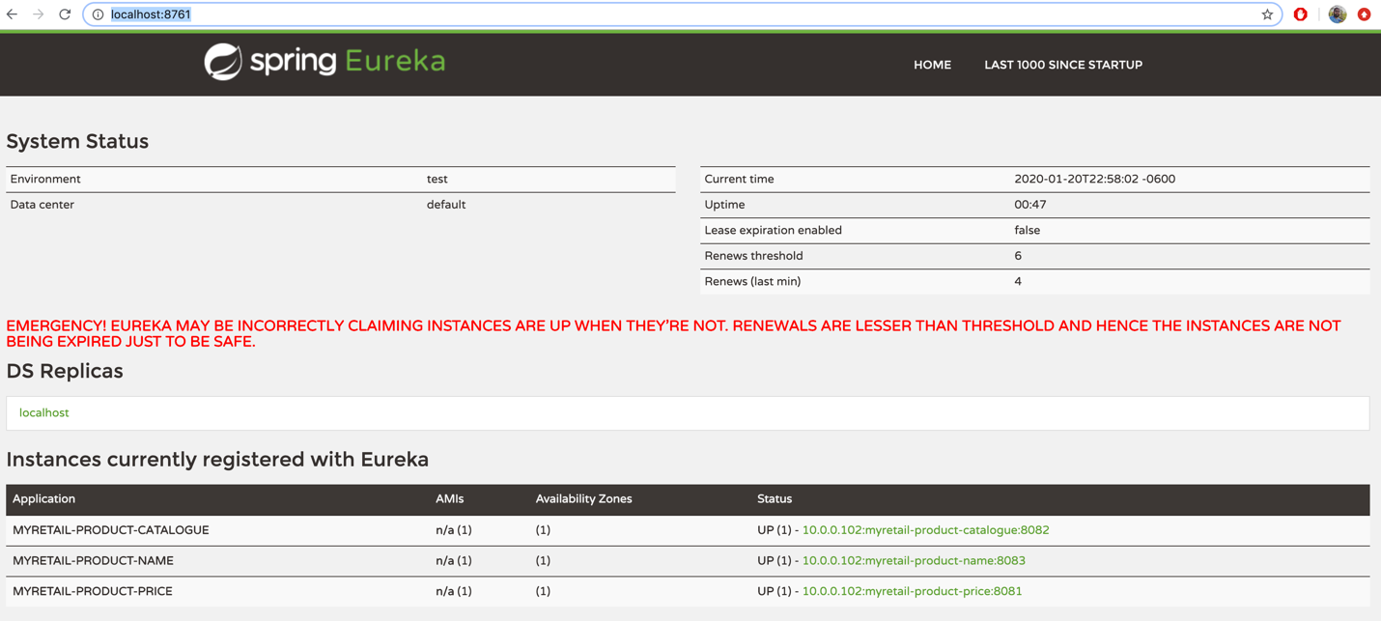

1. Last step is to execute on Browser

<http://localhost:8082/myretail/v1.0/product/13860428>

O/p

{

**"id"**:13860428,  
**"name"**:"The Big Lebowski (Blu-ray)",  
**"currentPrice"**:{

**"value"**:13.49,  
**"currencyCode"**:"USD"

}

}